U.S. Consumer Product Safety Commission – Fast Track Recall

Release Date: October 15, 2026

HatsanUSA Recalls Blitz Air Rifles Due to Risk of Serious Injury or Death from Projectile Hazard

Recall Summary

Name of Product: Blitz and Blitz 777 air rifles

Hazard: The recalled air rifles can fire unexpectedly when releasing the bolt before the air rifle is fully cocked, posing a risk of serious injury or death from projectile hazard.

Remedy: Replace
Consumers should stop using the recalled air rifles immediately, make sure they are unloaded and contact HatsanUSA for a free trigger assembly replacement which will be mailed along with instructions. If the consumer does not want to complete the replacement of the air rifle trigger assembly on their own, HatsanUSA will provide a prepaid package to ship the product to HatsanUSA for inspection and replacement.
Consumer Contact: HatsanUSA toll-free at 877-750-3375 from 8:30 a.m.
to 4 p.m. CT Monday through Friday, email at blitzrecall@hatsanusa.com or online at
https://hatsanairgunsusa.com/recalls/blitz-and-blitz-777-recall/ and enter password “Hatsan2026!” or https://hatsanairgunsusa.com and click “Warranty & Safety” and then “Recalls” for more information.

Recall Details

Units: About 16,170

Description: This recall involves all units of the Hatsan Blitz and Blitz 777 pellet shooting air rifles sold from February 2020 through March 2026. Both the Blitz and Blitz 777 pellet air rifles were sold in .22, .25 and .30 calibers. The pellet air rifles are gas operated and select-fire (semi-auto/full-auto) pre-charged pneumatic (PCP). They are black and feature a synthetic stock, a carbon fiber air tank mounted beneath the barrel and a rotary magazine feed. Serial numbers and manufacturing dates are engraved on the right side of the receiver above the bolt. On the left side of the receiver is the Hatsan logo, featuring a circular mark, with the word “HATSAN” next to a graphic of a bow and arrow. The model name “BLITZ” or “BLITZ 777” is also marked on the left side of the receiver.

Incidents/Injuries: The company has received one report of an accidental misfire. No injuries have been reported.
Sold at: In store and online at various sporting goods stores and gun shops nationwide, online at hatsanairgunsusa.com and catalog sales including Utah Airguns, Airgun Depot and Pyramyd Air from February 2020 through March 2026 for between $800 and $1,100.
Importer: HatsanUSA, Inc., of Bentonville, Arkansas
Manufactured in: Turkey
Photos
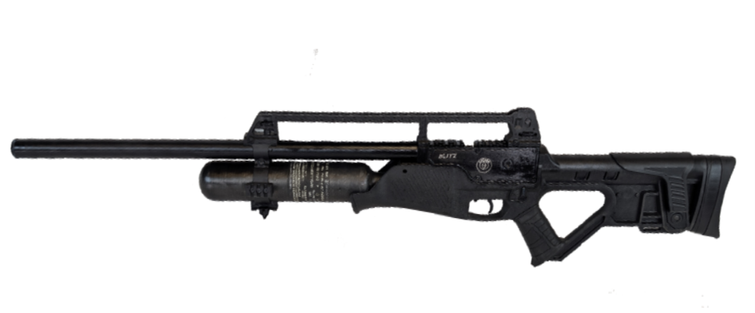
Recalled Hatsan Blitz Air Rifle

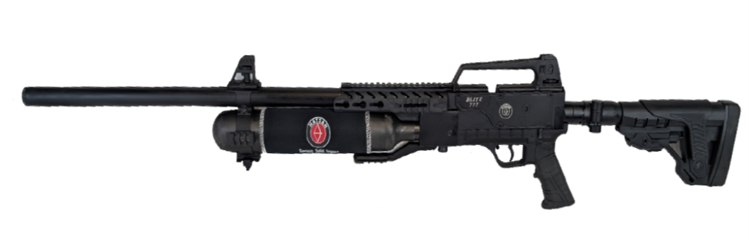
Recalled Hatsan Blitz 777 Air Rifle
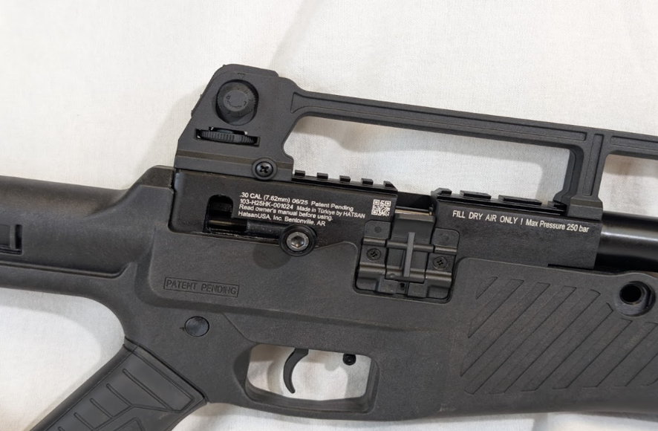
Recalled Hatsan Blitz Air Rifle showing location of serial number and manufacture date
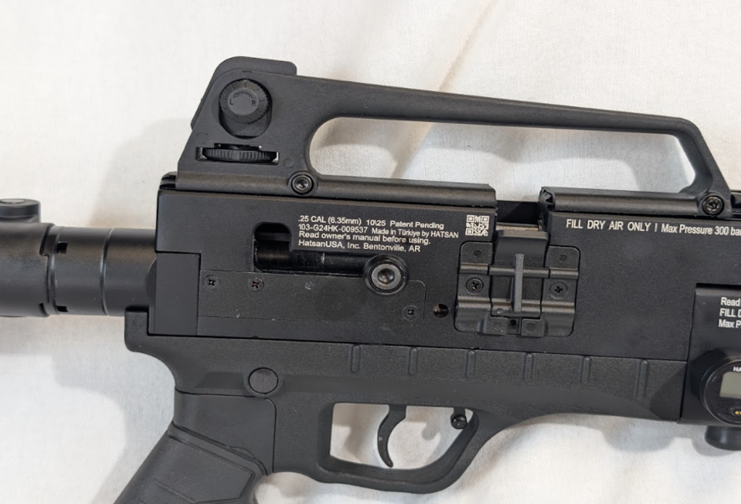
Recalled Hatsan Blitz 777 Air Rifle showing location of serial number and manufacture date

Fast Track Recall
About CPSC
CPSC is the federal agency charged with protecting the public from unreasonable risks of injury associated with thousands of types of consumer products. Deaths, injuries, and property damage from consumer product-related incidents cost the nation more than $1 trillion annually. Since the agency was established more than 50 years ago, CPSC has worked to ensure the safety of consumer products, contributing to a decline in related injuries.

Federal law prohibits any person from selling products subject to a Commission-ordered recall or to a voluntary recall undertaken in consultation with CPSC.

For lifesaving information:
- Visit CPSC.gov
- Sign up to receive our e-mail alerts
- Follow us on Facebook, Instagram, X, BlueSky, Threads, LinkedIn and Truth Social
- Report a dangerous product or a product-related injury on www.SaferProducts.gov
- Call CPSC’s Hotline at 800-638-2772 (TTY 800-638-8270)
- Contact a media specialist.

